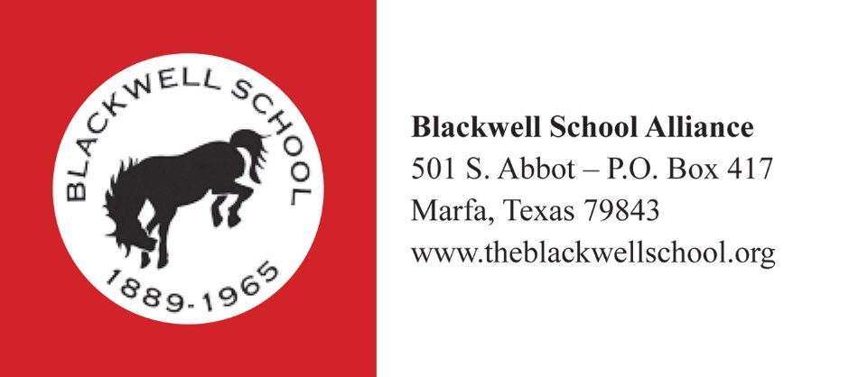

Sunday, August 6, 2017

For Immediate Release

UTSA RETURNS TO THE BLACKWELL SCHOOL TO PRESENT FINDINGS

Marfa, Texas

Students from the UT San Antonio graduate program in Historic Preservation Architecture return to the Blackwell School on Thursday, August 10, to present the findings of their recent site visit. The students spent a week at the Blackwell School in July as part of a summer seminar learning to conduct research necessary for a Historic Structure Report. The findings represent the pieces of a puzzle coming together to show a bigger picture.

Research in Marfa included investigations of the historic Blackwell School building to determine how and when it was constructed, review of historic documents and photographs, deed research, a Community Conversations event, and individual interviews with former students, educators, and community members.

The students’ work is one piece of the Blackwell School’s Historic Structure Report which will provide a road map to restoring the building in a way that is both compliant with historic preservation standards and honors the values the community holds for the building and the experiences associated with the Blackwell School.

Professor Dupont explains, “The Blackwell School has the potential to be a phenomenal resource for the community and the region. And to achieve that full potential it’s necessary to go through steps in a process. The Historic Structure Report is one of those steps.”

The Blackwell School Alliance invites former students of the Blackwell School, friends and neighbors, and everyone interested in the preservation of Marfa history to attend. The presentation is Thursday, August 10, at 6:00 p.m. at the Blackwell School. It is free and open to the public. The Blackwell School is located at the corner of South Abbott and Waco Streets in Marfa. For more information, please call Gretel Enck at 432.295.3359.

Photo Caption, Community Conversation: As part of the July site work, UTSA students led group conversations that examined the values people hold for the Blackwell School.

Photo Caption, Blackwell Crawl Space: Students Jen Ny and Thommy Sebastian investigated and documented building evidence in the crawl space under the Blackwell School.

